Report for internship task 5

**Name: Shoaib Ahmed**

**Internship iD: TN/IN02/PY/027**

**Task Objective:**

The purpose of this task is to gain understanding of threads, processes, and MongoDB.

**Code snippets:**

# Task 4: Insert 3 users in Database and fetch them

import sqlite3

# Step 1: Connect to database (file 'users.db' banega)

conn = sqlite3.connect("users.db")

cursor = conn.cursor()

# Step 2: Create table if not exists

cursor.execute("""

CREATE TABLE IF NOT EXISTS users (

id INTEGER PRIMARY KEY AUTOINCREMENT,

name TEXT,

email TEXT

)

""")

# Step 3: Insert 3 users

users = [

("Ali", "ali@example.com"),

("Saad", "saad@example.com"),

("Ayesha", "ayesha@example.com")

]

cursor.executemany("INSERT INTO users (name, email) VALUES (?, ?)", users)

conn.commit()

# Step 4: Fetch all users

cursor.execute("SELECT * FROM users")

rows = cursor.fetchall()

print("Users in Database:")

for row in rows:

print(row)

conn.close()

2: # Task 3: Add /about route in Flask app

from flask import Flask

app = Flask(__name__)

@app.route("/")

def home():

return "Hello Home"

@app.route("/about")

def about():

return "Hello About"

if __name__ == "__main__":

app.run(debug=True)

**screenshots:**

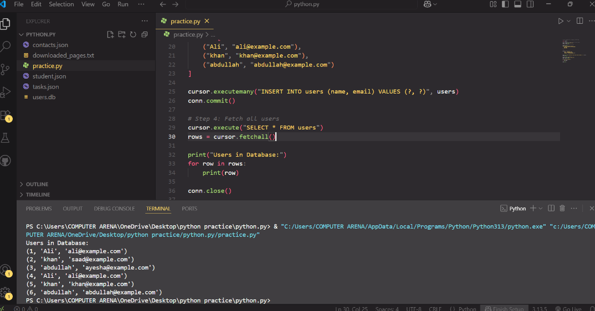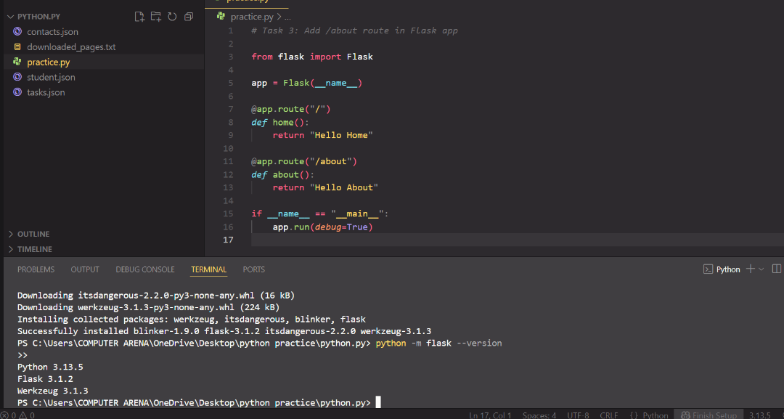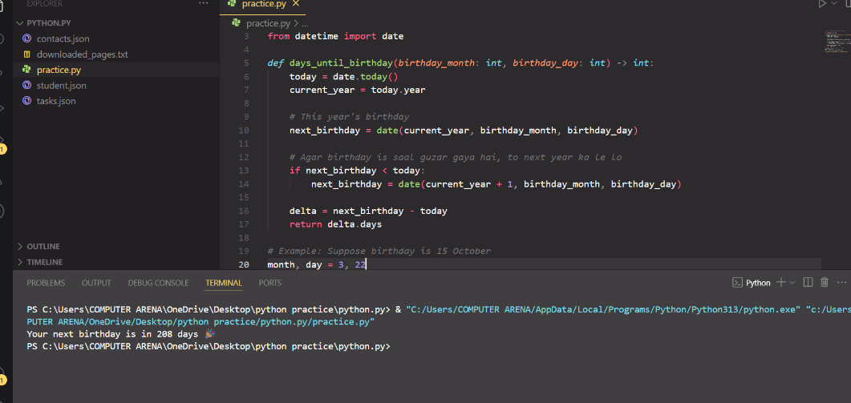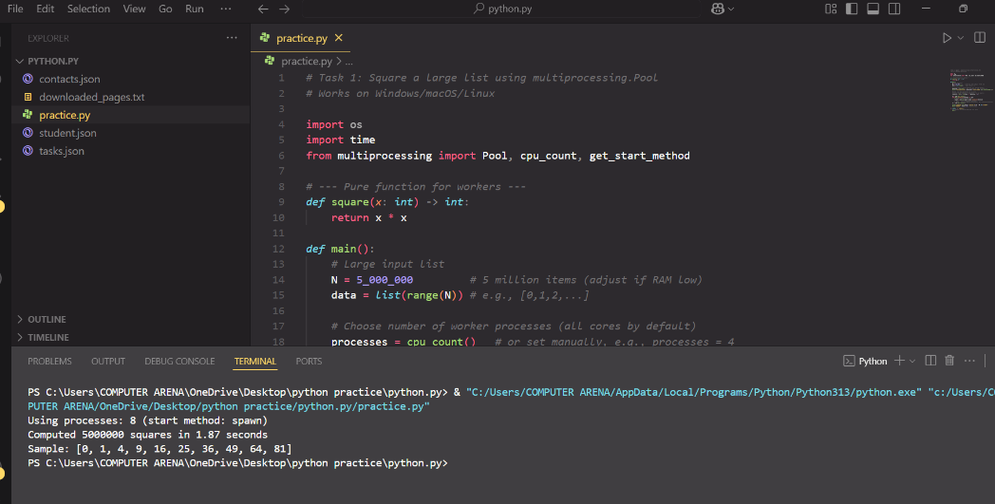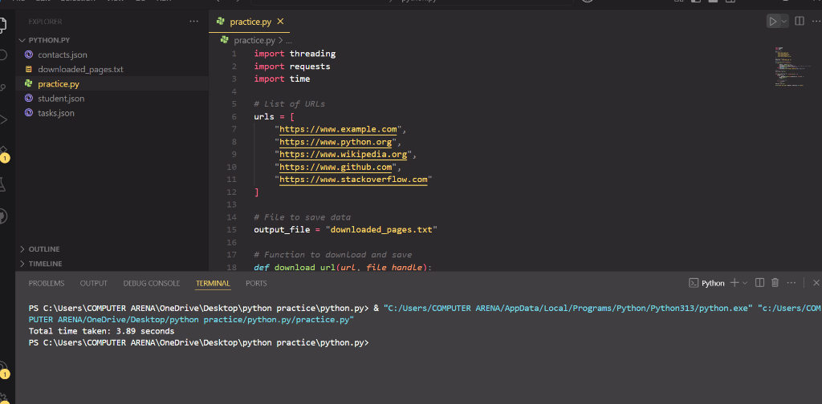

**Reflections:**

This activity helped me understand how to connect Python with a database. I made a table, inserted three user records, and then retrieved them to display on the screen. Through this process, I learned how information can be saved and accessed using basic SQL queries. It was a valuable practice as it introduced me to fundamental database operations, which are essential for developing real-world applications.